WEEKLY CYBERSECURITY TOOLS TRACK
Netcat (nc)
Module 2 — Port Scanning & Banner Grabbing
Hands-on lab practicals using Netcat from a Kali Linux VM against a Metasploitable2 target VM on a private VirtualBox host-only network.
Prepared by
Emmanuel Aidoo
Lab environment: Kali Linux (attacker) · Metasploitable2 (target) · Oracle VirtualBox

Table of Contents
Module Overview 3
1. Port Range Scan (nc -zv) 4
2. Single Port Scan (nc -zvn) 5
3. Range Scan with Timeout and Numeric-Only Output (nc -znvw) 7
4. Banner Grabbing (HTTP on Port 80) 8
Key Takeaways 9

Module Overview
Besides moving files and chat text (Module 1), Netcat can act as a simple reconnaissance tool. Because it can open a raw TCP connection to any address and port, it can check whether a port is open (port scanning) and read what a service says about itself when you connect to it (banner grabbing).
This module documents four practicals run from the Kali VM against the Metasploitable2 VM at 192.168.56.102: a port range scan, a single-port check, a range scan using a timeout and numeric-only output, and an HTTP banner grab against port 80. All activity was carried out inside my own isolated lab network.
ENVIRONMENT
Setting | Detail
Attacker VM | Kali Linux (Oracle VirtualBox)
Target VM | Metasploitable2 — 192.168.56.102 (confirmed with ip a, interface eth0)
Network | VirtualBox host-only adapter (192.168.56.0/24)
Tool | Netcat (nc), traditional version, as installed on Kali and Metasploitable2

NETCAT FLAGS USED IN THIS MODULE
Flag | Meaning
-z | Zero-I/O mode: connect to the port and close straight away without sending any data (used for scanning)
-v | Verbose: print results such as "open" for each port that answers
-n | Numeric only: do not attempt DNS lookups on the target address
-w <seconds> | Timeout: give up on a connection attempt after this many seconds

1. Port Range Scan (nc -zv)
The first practical used Netcat to check every port from 1 to 1000 on the Metasploitable2 target and report which ones accept a connection. Before scanning, ip a was run on Metasploitable2 to confirm the target's address.
COMMANDS USED
# On Metasploitable2 — confirm the target address
$ ip a

# On Kali — scan ports 1 to 1000
$ sudo nc -zv 192.168.56.102 1-1000

What I Learned
The -z flag makes Netcat connect to each port and immediately close the connection without sending anything, and -v makes it print a line for every port that answers. Without -v the scan would run silently, so the two flags are normally used together. The 1-1000 at the end is the port range.
The scan found 12 open ports. Netcat lists them from the highest port down to the lowest (514 first, 21 last). The name in brackets next to each port, such as (http) or (ssh), comes from the system's list of well-known port numbers; it is a label for the port, not proof of what is actually running there. The line "inverse host lookup failed" appears at the top because Netcat tried to resolve the target's name and the lab has no DNS server to answer.
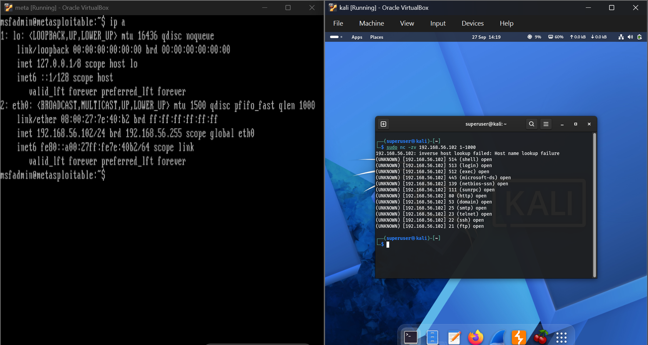
Figure 1 — ip a on Metasploitable2 (left) confirming 192.168.56.102, and the range scan from Kali (right) listing the open ports.
RESULT SUMMARY
Item | Observation
Target | 192.168.56.102 (Metasploitable2, eth0)
Command | sudo nc -zv 192.168.56.102 1-1000
Ports scanned | 1 to 1000
Open ports found | 12
Open ports and labels | 21 ftp, 22 ssh, 23 telnet, 25 smtp, 53 domain, 80 http, 111 sunrpc, 139 netbios-ssn, 445 microsoft-ds, 512 exec, 513 login, 514 shell
Lookup message | "inverse host lookup failed" shown once (no -n flag used)

My Observation
Twelve open ports in the first 1000 is a large attack surface for one machine. Several of them are old, unencrypted services: telnet (23), ftp (21) and the three r-services (exec, login and shell on 512 to 514). This is expected for Metasploitable2, which is built to be vulnerable, but on a real system each of those would be a finding to investigate. I also want to remember that the service names are only guesses from the port number, so a service on a non-standard port would be labelled wrongly, or not labelled at all.

2. Single Port Scan (nc -zvn)
Netcat can also be pointed at just one port, which is a quick way to check whether a specific service is reachable. This practical checked SSH on port 22.
COMMANDS USED
# On Kali — check a single port
$ sudo nc -zvn 192.168.56.102 22

What I Learned
This is the same -z and -v combination as before, with one port instead of a range. The extra -n flag tells Netcat not to try resolving the address to a hostname, which is why the "inverse host lookup failed" line from the range scan does not appear this time and the result is a single clean line. Flags can also be joined in any order, so -zvn, -nvz and -z -v -n all mean the same thing.
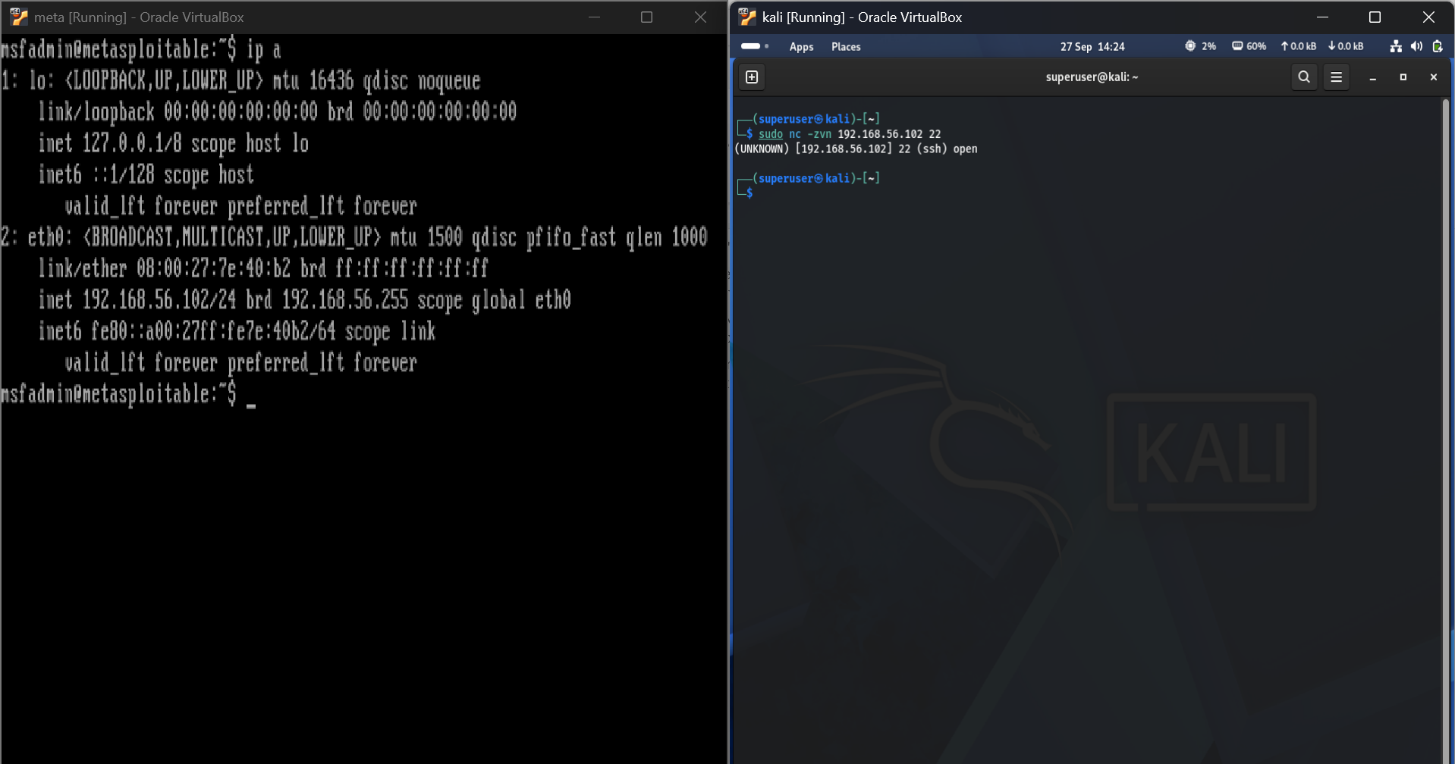
Figure 2 — Metasploitable2 (left) showing its address, and Kali (right) confirming port 22 is open.
RESULT SUMMARY
Item | Observation
Command | sudo nc -zvn 192.168.56.102 22
Result | (UNKNOWN) [192.168.56.102] 22 (ssh) open
Lookup message | Not shown, because -n skips the DNS lookup
Consistency | Matches port 22 (ssh) in the range scan from Section 1

My Observation
"Open" only tells me that the TCP connection was accepted. The (ssh) label is still just the standard name for port 22, so this scan alone does not prove an SSH server is really listening there. To confirm what a port is running, I need to connect and read what the service sends back, which is exactly what banner grabbing does in Section 4. A single-port check is most useful for quickly verifying one service, for example after changing a firewall rule.

3. Range Scan with Timeout and Numeric-Only Output (nc -znvw)
The third practical repeated the 1 to 1000 range scan with two extra options: -n to skip name lookups and -w 3 to set a three-second timeout on each connection attempt.
COMMANDS USED
# On Kali — range scan with numeric-only output and a 3 second timeout
$ nc -znvw 3 192.168.56.102 1-1000

What I Learned
The -w flag takes a number of seconds as its argument, so the 3 that follows it belongs to -w and is not part of the address. It stops Netcat waiting too long on a port that never answers. This matters on hosts protected by a firewall that silently drops packets, where each attempt could otherwise hang for a long time and make a range scan very slow.
The output is cleaner than in Section 1: the -n flag removed the "inverse host lookup failed" line, so the screen shows only the open ports. This scan was also run without sudo and returned exactly the same 12 open ports, so Netcat does not need root privileges to scan, even for ports below 1024. It simply makes ordinary TCP connections, the same idea as the TCP connect scan (-sT) I practised with Nmap.
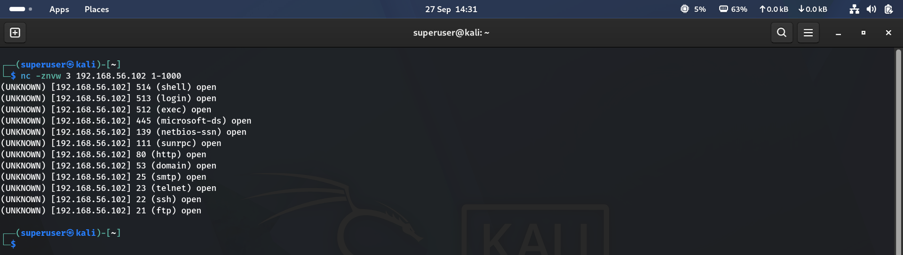
Figure 3 — Range scan using -n and a 3 second timeout, returning the same 12 open ports.
RESULT SUMMARY
Item | Observation
Command | nc -znvw 3 192.168.56.102 1-1000 (no sudo)
Open ports found | 12, identical to Section 1 (21, 22, 23, 25, 53, 80, 111, 139, 445, 512, 513, 514)
Lookup message | Not shown, because -n skips the DNS lookup
Timeout | 3 seconds per connection attempt
Privileges | Ran without sudo with the same result

My Observation
Two habits to keep from this practical: add -n to remove pointless DNS lookups, and add -w to protect against slow or filtered targets. On this lab host the timeout is mostly a safeguard, because a closed port on a local machine normally refuses the connection straight away. Against a firewalled host that drops packets, the timeout would make a much bigger difference. The identical results with and without sudo also show that the extra privileges I added in Sections 1 and 2 were not needed.

4. Banner Grabbing (HTTP on Port 80)
Banner grabbing means connecting to a service and reading what it reveals about itself, such as the software name and version. Port 80 was identified as open in the earlier scans, so this practical connected to it and asked the web server to describe itself.
COMMANDS USED
# On Kali — open a raw connection to the web server
$ nc -v 192.168.56.102 80

# Then type this request, followed by a blank line (press Enter twice)
HEAD / HTTP/1.0

What I Learned
The first command opens a raw TCP connection to port 80. Netcat reports the port as open and then simply waits with a blinking cursor (Figure 4). Nothing appears because web servers stay silent until the client sends a request, unlike services such as FTP, SSH or SMTP, which usually announce themselves as soon as you connect.
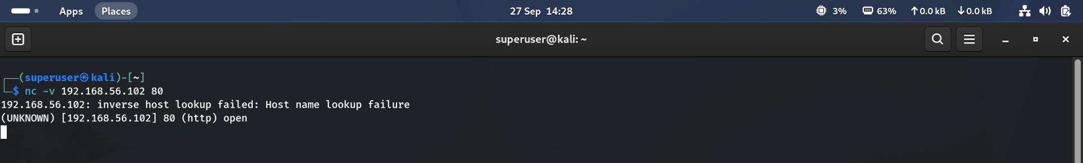
Figure 4 — Connection to port 80 established; the server is waiting for a request.
Typing HEAD / HTTP/1.0 and pressing Enter twice sends a minimal HTTP request. The HEAD method asks for the response headers only, without the page content, and the blank line tells the server the request is complete. The server replied with HTTP/1.1 200 OK and a set of headers (Figure 5), then closed the connection because of the Connection: close header, which returned me to the shell prompt.
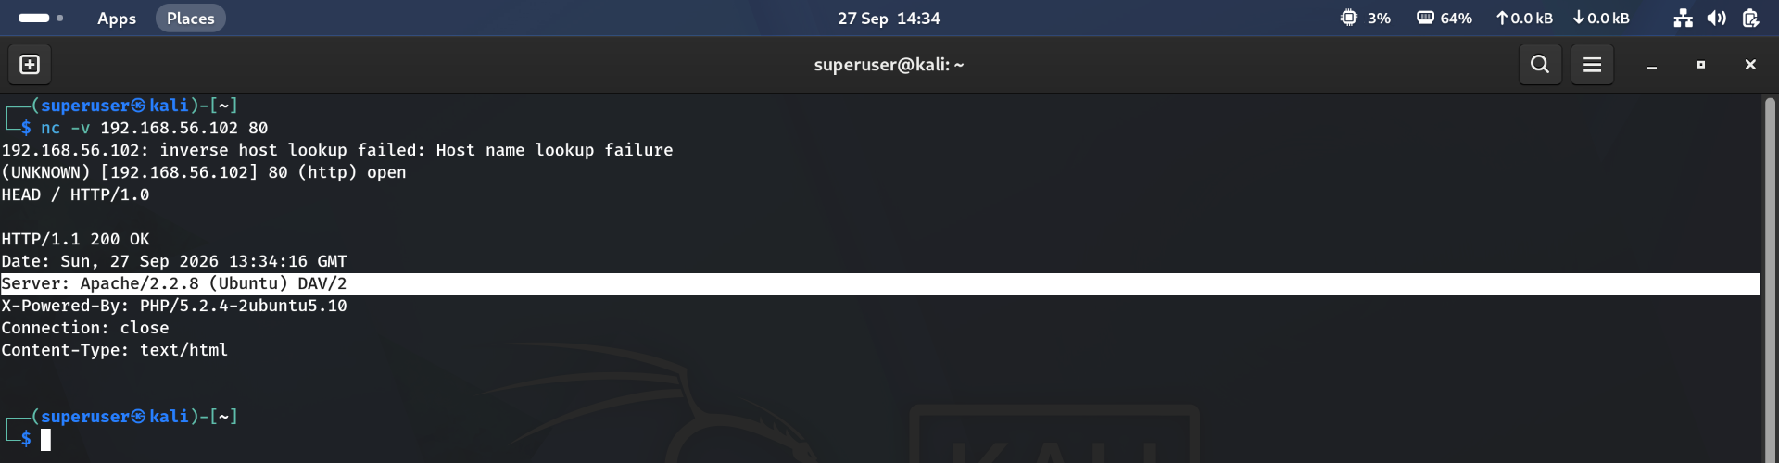
Figure 5 — Response headers from the web server, with the Server line highlighted.
RESULT SUMMARY
Item | Observation
Target | 192.168.56.102, port 80 (http)
Request sent | HEAD / HTTP/1.0
Status | HTTP/1.1 200 OK
Web server | Apache/2.2.8 (Ubuntu) DAV/2
Backend technology | X-Powered-By: PHP/5.2.4-2ubuntu5.10
Other headers | Connection: close, Content-Type: text/html, Date: Sun, 27 Sep 2026 13:34:16 GMT

My Observation
With one short request the server told me its exact web server version (Apache 2.2.8), the operating system family (Ubuntu) and the exact PHP version (5.2.4). Both are very old, out-of-support releases, which is why this lab machine makes good practice: in a real assessment I would look these exact versions up in a vulnerability database. The same information is what defenders should hide. Setting Apache's ServerTokens to Prod and turning PHP's expose_php off reduces how much the headers reveal.

Key Takeaways
- nc -zv <ip> <start>-<end> scans a range of TCP ports: -z connects without sending data and -v prints the ones that are open.
- Add -n to skip DNS lookups (cleaner and faster output) and -w <seconds> to stop a scan hanging on filtered ports.
- Netcat's port scan is a plain TCP connect scan, so it needs no root privileges. The service names it prints come from port numbers, not from checking the service.
- Web servers stay quiet until asked. Sending HEAD / HTTP/1.0 followed by a blank line returns the response headers, which can reveal the server software and version.
- Exposed version strings turn a vague open port into a specific, researchable target, so hiding them is a simple but worthwhile hardening step.
Next up: banner grabbing on the other open services (FTP on 21, SSH on 22 and SMTP on 25), then bind and reverse shells.

